Results of the Trigger Run Sizes

Sara Miller

June 19, 2017

# Background

The trigger run sizes on the Scform sheet of the SFMM (Catch-CPUE) model were updated for the Tah for the Tahltan stock in the D-10641 and D-108 fishery.

**Prior results (used in models from 2014-2016)** Data used from 1994 through 2013.Data through 2011 is SPA and data from 2012 on is GSI.

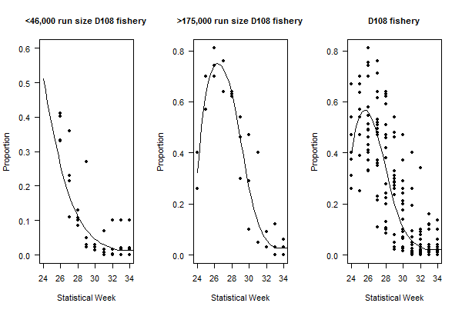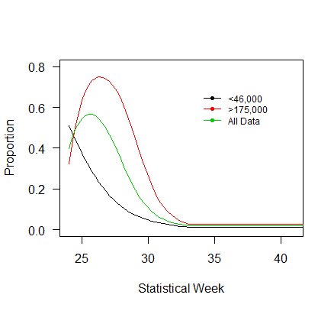

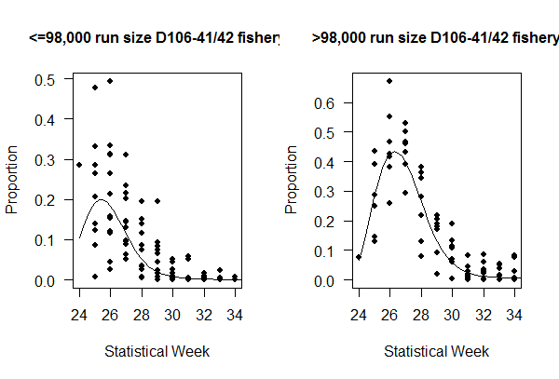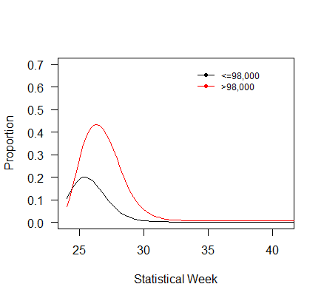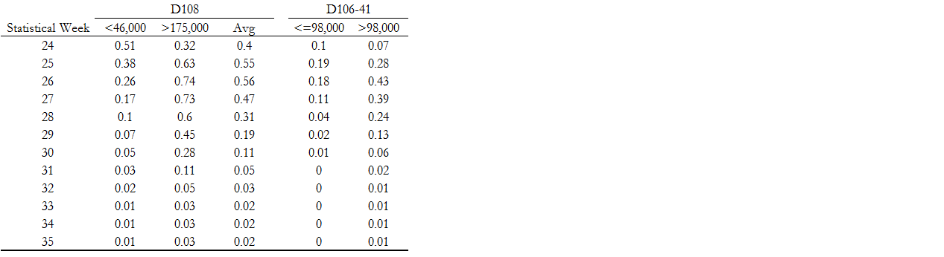

**Current results (used in models from 2017):**

